|  |
| --- |
| Software Engineering CSC 4350 |
| Tickr |
| Spring 2018 |

**Challenges and Risks :**

·         What is the single most serious challenge you see in developing the product on schedule?

o    As no one in the group has extensive knowledge working on mobile apps we will all have to learn how to implement a program in a mobile environment. This may lead to unexpected delays or unforeseen challenges. To combat this all five members of our group will be working together to learn about mobile app development, so that if anyone falls behind the others can help sort out the issue.

·         What are 2+ risks you can foresee in completing this project?

o    This project relies on various APIs to get info on the users finances, stock prices, and crypto-currency rates. If any of these have temporary interruptions or stop being supported the app will lose functionality. To minimize this risk we are using well established APIs that have a background of being reliable and consistently supported, meaning downtime should be minimal if at all.

o    This project will be developed as a mobile app, which no one on the team has much experience with mobile programming this could lead to delays while group members learn how to implement an android app. To lessen the effect of this we will all be learning together so that if any one person encounters an issue other may be able to assist.

**Tasks**

* Identify principal tasks
* Identify risks & plan for them
* divide tasks among group and make schedule
* Create a GitHub & Slack and invite everyone to them
* Create a Problem Statement
* Identify the System Requirements & model them in UML
* Develop use cases for the project & list their requirements
* Create a video detailing the problem statement for the project
* Create Video

**Schedule:**

|  |  |  |  |  |  |  |
| --- | --- | --- | --- | --- | --- | --- |
| **Task** | **Effort (person-days)** | **Duration (hours/or days/ etc.)** | | **Dependencies** | **Allocated to** | **Monitoring** |
| **Min** | **Max** |
| Outline Plan   * Hardware Software Requirements * Challenge and Risks | 2 days | 2 days | 3 days |  | Austin Tyler | Git Hub |
| Scheduling | 1 day | 1 day | 2 days |  | Natsai Ndebele | Git Hub |
| Version Control set-up | 1 day | 30 min | 1 hour |  | Justin Little | Git Hub |
| Update Git-hub Project Tracker | 1 day | 30 min | 1 hour |  | Justin Little | Git Hub |
| Problem Statement | 1 day | 1 day | 2 days |  | Haroon Qahtan | Git Hub |
| System requirements   * Read chapter 5 * UML Activities diagram | 2 days | 2 days | 3 days |  | Charlie Neopane |  |
| Use case diagrams   * Read chapter 4 | 2 days | 2 days | 3 days | System Requirements | Justin Little |  |
| Virtual Check-in | 30 min | 30 min | 1 hour | All tasks above | All | Slack |
| Video Script/ Plan | 30 min | 30 min | 1 hour | Problem Statement | Natsai Ndebele |  |
| Video Recording | 30 min | 30 min | 1 hour | Video Script | All |  |
| Video Upload | 30 min | 30 min | 1 hour | Video Recording | Natsai Ndebele |  |

**Method to calculate effort used: Experience Method**

Most of the tasks were given up to a day, because we had to take time to read and understand how to correctly do the tasks as we had 0 up to a little experience with some of the tasks we had to do.

Factors that were also taken into consideration were the time it would take to attend to some tasks, because of school interfering. Time taken to clarify issues by asking the team lead who would then speak to the professor.

**Monitoring and Reporting Mechanisms:**

To monitor our progress, we are using Git Hub progress tracker Kanban boards. With these what we will do is when a task is in progress its on the progress board, and when complete its on the complete. Another method to monitor and report to each other is slack, which we will also use to communicate any progress or issues experienced.

Before recording the video, we will also have a team meeting for all members to give an update on all their various tasks and what needed to be done.

**Problem Statement:**

What is your product, on a high level?

* Our product is an app that allows users to track their finances. Whether that’s bank balance, stock portfolios and even cryptocurrency portfolios. The users can create an account, link their bank, and then begin to add multiple investments that they have made. Therefore, our application will keep track of all those investments and then give an overall worth of the portfolio based on those multiple investments.

Whom is it for?

* Our product is for anyone who needs a way to keep track of their finances and investments. In this context, investments being stocks and cryptocurrencies.

What problem does it solve?

* Keeping up with all your finances might be time consuming especially if you invest in a personal portfolio. Therefore, our app solves the problem of keeping track of the finances happening in your bank as well as the investments that the user makes on either stocks or cryptocurrencies.

What alternatives are available?

* There are multiple applications out there that track personal finances such as **Personal Capital Finance, SigFig Wealth Management, Ticker: Stocks Portfolio Manager, and Mint.**

Why is this project compelling and worth developing?

* Our project does what the other apps do, and that is to combine multiple assets into one application. The apps mentioned above focus on one type of tracking. Either it is stocks or personal bank finance. What we are trying to do with Tickr is to create a platform where the average user can include multiple types of finances that they own.
* This project is worth developing because it will need the use of multiple API’s and we believe that learning to work with API’s is very crucial when working in the real world. Therefore, it is a good way for us to practice and learn new methods.

Describe the top-level objectives, differentiators, target customers, and scope of your product.

* Top level objectives is to research more on how to retrieve financial information from our users. Also create a flow chart and basic design to see how our app is going to look like and how it will users  be able to interact with it.
* Our main differentiator is that a user can add multiple sources of finance activity. This is very unique to our app since there isn’t an application in the market that allows users to include bank activity, stock investments as well as cryptocurrency investments. Also our application will be on mobile since we believe it will reach a greater audience based on the rise of mobile use as opposed to web clients.
* Our target customers are people who have a bank account and who also invest or want to invest in either stocks or cryptocurrencies to create a portfolio. Our target audience also needs a way to keep track of all movements in their portfolios as well as keep track of their overall worth.
* As of right now, the scope of our product is targeting multiple sources of income/wealth. As well as creating the application on a mobile device that being on the Android platform.

What are the competitors and what is novel in your approach?

* As mentioned early on, some of the competitors out there are **Personal Capital Finance, SigFig Wealth Management, Ticker: Stocks Portfolio Manager, and Mint.**
* However, our approach to this application is novel because we are not only focusing on one source of income/wealth. Whereas the other applications are focused on either bank tracking or portfolio tracking. Our goal is to combine the two to give our users an overall value of their wealth.

Make it clear that the system can be built, making good use of the available resources and

technology.

* The system will be built on the Android platform, and we already have some team members who are familiar with this technology.
* Also, we understand what goes into investing in stocks and cryptocurrencies, therefore, we are working with a familiar domain.
* In order to retrieve data to input into our application, we have already researched some API’s that allow for stocks and cryptocurrency price retrieval such as Google Finance API and Coinbase API. Also we have been researching to find a suitable bank API and we believe that Plaid’s API works best with our application in order to retrieve bank info.

What is interesting about this project from a technical point of view?

* The heavy use of API’s is very interesting in this project. Learning to work with them and implanting them is really game changing. The API’s we are working with are all finance based however one is just for banking while the others are to retrieve stock and cryptocurrency information in real time.
* Also, this project will be developed on a mobile platform (Android) which means that it will be available just a few taps away.

**System Requirement Description**

**Brief Description of Tickr:** The system which helps to keep track of individual’s finances like bank balance, stock portfolios along with cryptocurrency portfolios.

**User inputs:** Sign up/Login credentials, Option to select Bank, Coinbase, Stock Market.

**Requirement Description:** The user will be able to keep track of all the transaction of bank, and Coinbase along with monitor the stock market of selected stock.

>>  User will Sign up/Login in to Tickr

>>  User will have three options

**I. Bank**

·      Uses Plaid API to declare Bank name

·      Using the credentials, verify the information and Tickr will pull bank account transaction

**II. Coinbase**

·      User inputs login information for Coinbase

·      Tickr will pull the report of cryptocurrency balances

**III. Stock Market**

·      User will pick one or more stocks

·      After seeing the user selection, Tickr will use the Google Finance API to show the current rates for those selected stocks.

**Outputs:** Full report of spending graph, Coinbase balances, stock prices, current cryptocurrency rates.

***Based on the above system requirement, the context model is drawn below:***

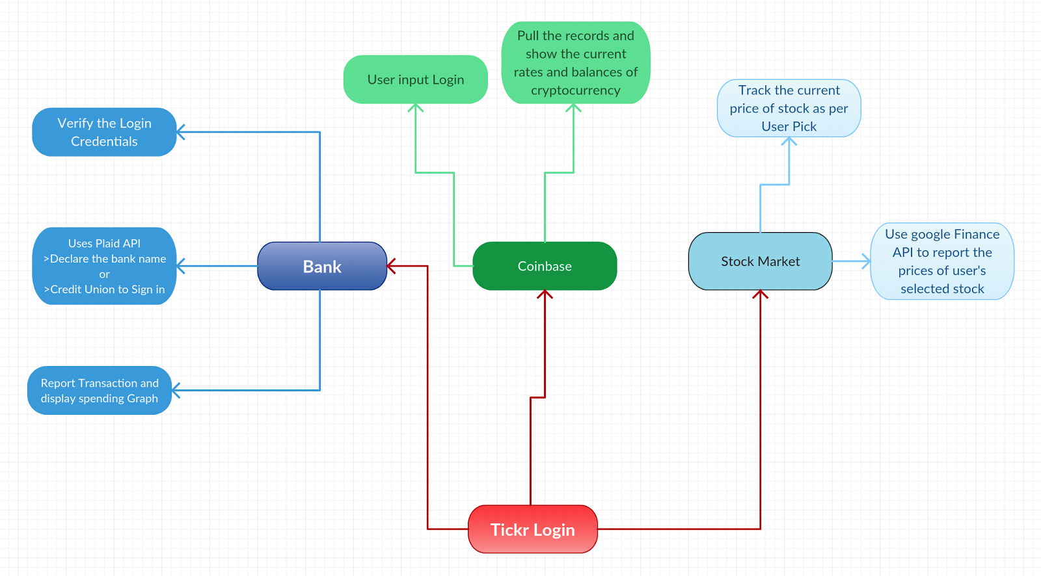

**Use Cases**

|  |  |
| --- | --- |
| **Tickr Use Case #1 - Full Functionality** | |
| Actors | Finance-tracking user, User Log-In (Facebook or Google), Bank or Credit Union, Coinbase Account, NASDAQ & NYSE stocks |
| Description | The user may log onto Tickr to check their personal finances, and current stock prices & cryptocurrency rates for investing. To access the user’s personal information that is encrypted and secured, a login via Facebook or Google is required. When setting up the Tickr account for the first time, you’ll enter your Bank name, account number, and routing number. You can also set up another account later! Optionally, you can set up your Coinbase account, and track all of your stocks & view the current rates! The Personal Finance tab will contain balance(s), recent transactions, and a spending graph. Also, the following page will contain current cryptocurrency rates, and stock prices to make the best investment decisions! |
| Data | Tickr Login (Facebook or Google), Bank Information, Coinbase login |
| Stimulus | User follows prompts to create/log into Tickr account and inputs bank, Coinbase, and stock information, and submits information to view all data |
| Response | Confirmation at every step that credentials were accepted; Full report of personal financial information (balances, transactions, spending graph); Coinbase balance(s) & current cryptocurrency rates and stock prices |
| Comments | The user must input at least one bank account to have content in the Personal Finance tab and at least 3 stocks to view content in the Investment tab, but logging into Coinbase is optional. |

|  |  |
| --- | --- |
| **Tickr Use Case #2 - Personal Finance Only** | |
| Actors | Finance-tracking user, User Log-In (Facebook or Google), Bank or Credit Union, |
| Description | The user may log onto Tickr to check their personal finances. To access the user’s personal information that is encrypted and secured, a login via Facebook or Google is required. When setting up the Tickr account for the first time, you’ll enter your Bank name, account number, and routing number. You can also set up another account later! The Personal Finance tab will contain balance(s), recent transactions, and a spending graph. The investment tab will give the user the option to link their Coinbase account or track stocks later. |
| Data | Tickr Login (Facebook or Google), Bank Information. |
| Stimulus | User follows prompts to create/log into Tickr account and inputs bank information. |
| Response | Confirmation at every step that credentials were accepted; Full report of personal financial information (balances, transactions, spending graph) |
| Comments | The user must input at least one bank account to have content in the Personal Finance tab. |

|  |  |
| --- | --- |
| **Tickr Use Case #3 - Personal Finance & Crypto Tracker** | |
| Actors | Finance-tracking user, User Log-In (Facebook or Google), Bank or Credit Union, Coinbase Account |
| Description | The user may log onto Tickr to check their personal finances, and cryptocurrency rates for investing. To access the user’s personal information that is encrypted and secured, a login via Facebook or Google is required. When setting up the Tickr account for the first time, you’ll enter your Bank name, account number, and routing number. You can also set up another account later! Optionally, you can set up your Coinbase account, view your balances & the current rates! The Personal Finance tab will contain balance(s), recent transactions, and a spending graph. Also, the following page will contain current cryptocurrency rates and Coinbase balances. |
| Data | Tickr Login (Facebook or Google), Bank Information, Coinbase login |
| Stimulus | User follows prompts to create/log into Tickr account and inputs bank & Coinbase information and submits information to view all data |
| Response | Confirmation at every step that credentials were accepted; Full report of personal financial information (balances, transactions, spending graph); Coinbase balance(s) & current cryptocurrency rates. |
| Comments | The user must input at least one bank account to have content in the Personal Finance tab and sign into their Coinbase account. |

|  |  |
| --- | --- |
| **Tickr Use Case #4 - Personal Finance & Stock Tracker** | |
| Actors | Finance-tracking user, User Log-In (Facebook or Google), Bank or Credit Union, NASDAQ & NYSE stocks |
| Description | The user may log onto Tickr to check their personal finances, and current stock prices for investing. To access the user’s personal information that is encrypted and secured, a login via Facebook or Google is required. When setting up the Tickr account for the first time, you’ll enter your Bank name, account number, and routing number. The Personal Finance tab will contain balance(s), recent transactions, and a spending graph. Also, the following page will contain stock prices to make the best investment decisions! |
| Data | Tickr Login (Facebook or Google), Bank Information, and stocks |
| Stimulus | User follows prompts to create/log into Tickr account and inputs bank and stock information, and submits information to view all data |
| Response | Confirmation at every step that credentials were accepted; Full report of personal financial information (balances, transactions, spending graph) and current stock prices |
| Comments | The user must input at least one bank account to have content in the Personal Finance tab and select stocks to view content in the Investment tab. |

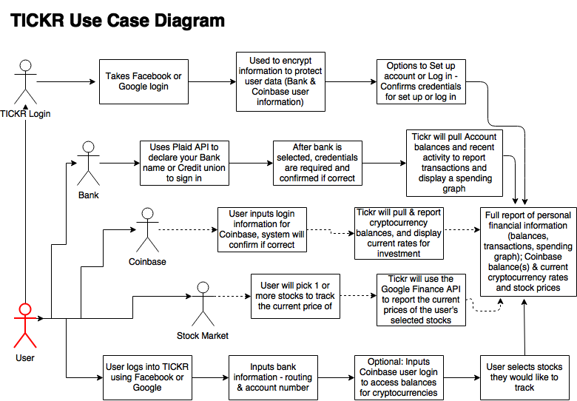

**Appendix A:**

Project Video Link:

<https://youtu.be/5r5EhSzsBiA>

**Appendix 2:**

Git hub link: <https://github.com/Justin5197/Tickr>

Screen shots:

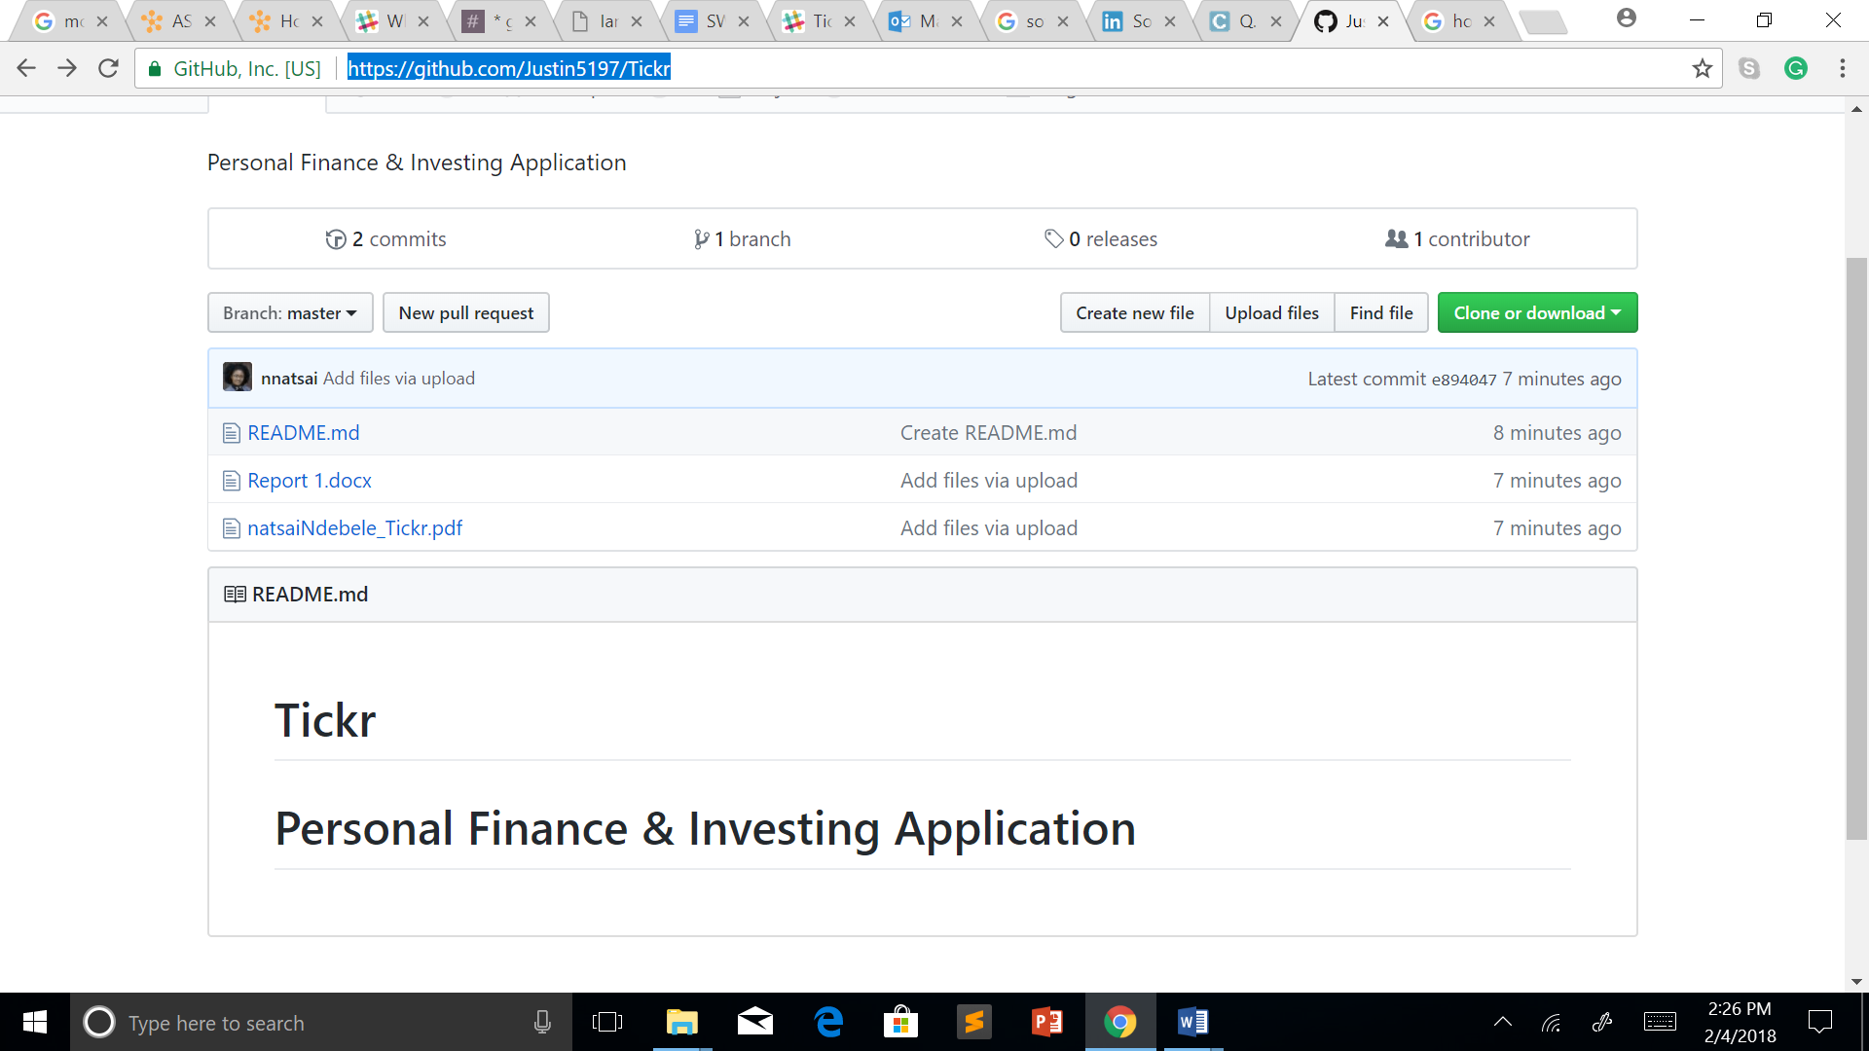

Git hub progress tracker:

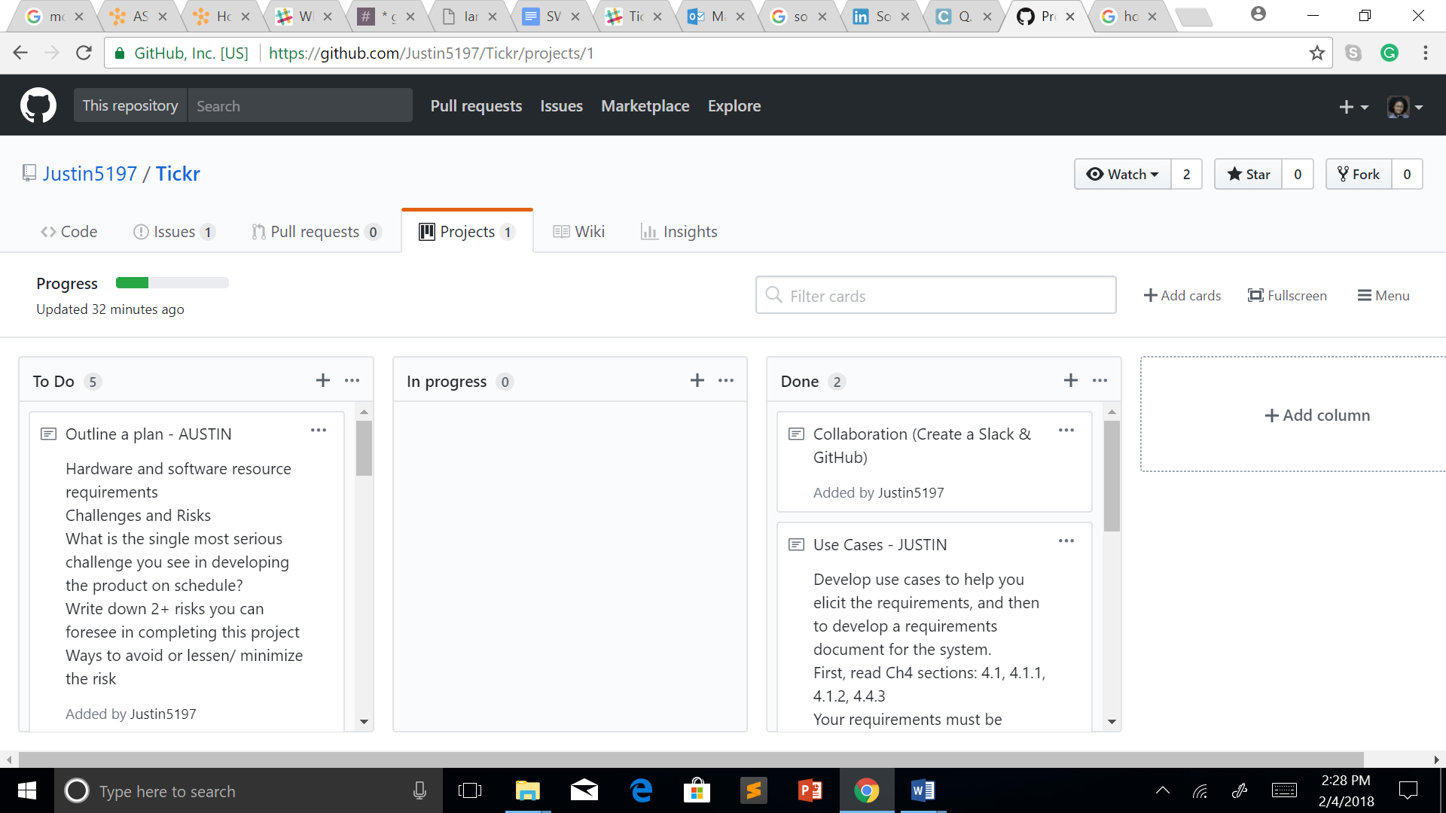

**Appendix C:**

Slack Channel

